**Practical No.18**

**Aim:** Create an android application to parse the data using JSON Object methods and set it in the Text view(Employee name and Salary stored in JSON format)

**Objective:** To understand the working of JSON (Java Script Object Notation).

**Steps:-**

Step 1:- Write your JSON

[ {

“name” : “jagruti”,

“salary” : “100000” },

{

“name” : “priyanka”,

“salary” : “200000” },

{

“name” : “akshat”,

     “salary” : “300000”

   }]

Step 2:-  validate a JSON on [www.jsonlint.com](http://www.jsonlint.com)

Step 3:- Once you complete the validation process save your JSON on [www.npoint.io](http://www.npoint.io)

Step 4:- Lock your Json  and copy the URL . you have to use that URL in your Program.

**Code:**

**activity_main.xml:-**

<?xml version="1.0" encoding="utf-8"?>  
<RelativeLayout  
xmlns:android="http://schemas.android.com/apk/res/android"  
xmlns:app="http://schemas.android.com/apk/res-auto" xmlns:tools="http://schemas.android.com/tools"  
 android:layout_width="match_parent"  
 android:layout_height="match_parent"  
 tools:context=".MainActivity">  
 <Button  
 android:id="@+id/button"  
 android:layout_width="match_parent"  
 android:layout_height="68dp"  
 android:text="Fetch Data" />  
 <ScrollView  
 android:layout_width="match_parent"  
 android:layout_height="match_parent"  
 android:layout_below="@+id/button">  
 <TextView  
 android:id="@+id/textView5"  
 android:layout_width="wrap_content"  
 android:layout_height="wrap_content"  
 android:layout_alignParentStart="true"  
 android:hint="displays JSON object"  
 android:scrollbarStyle="insideInset"  
 android:textAlignment="center"  
 android:textAppearance="@style/TextAppearance.AppCompat.Medium"  
 android:textSize="24sp" />  
 </ScrollView>  
</RelativeLayout>

**MainActivity.java**

package com.example.json_demo;  
import androidx.appcompat.app.AppCompatActivity;  
import android.os.Bundle;  
import android.os.Bundle;  
import android.view.View;  
import android.widget.Button;  
import android.widget.TextView;  
public class MainActivity extends AppCompatActivity {  
 public static TextView *data*;  
 Button click;  
 @Override  
 protected void onCreate(Bundle savedInstanceState) {  
 super.onCreate(savedInstanceState);  
 setContentView(R.layout.*activity_main*);  
 *data*=(TextView)findViewById(R.id.*textView5*);

click=(Button)findViewById(R.id.*button*);  
 click.setOnClickListener(new View.OnClickListener() {  
 @Override  
 public void onClick(View view) {  
 FetchData process=new FetchData();  
 process.execute();  
 } }); }}

**FetchData.java**

package com.example.json_demo;  
  
import android.os.AsyncTask;  
import com.example.json_demo.MainActivity;  
import org.json.JSONArray;  
import org.json.JSONException;  
import org.json.JSONObject;  
import java.io.BufferedReader;  
import java.io.IOException;  
import java.io.InputStream;  
import java.io.InputStreamReader;  
import java.net.HttpURLConnection;  
import java.net.MalformedURLException;  
import java.net.URL;  
 public class FetchData extends AsyncTask {  
 String data = " ";  
 String dataParsed=" ";  
 String singleParsed=" ";  
 @Override  
 protected Object doInBackground(Object[] objects) {  
 try {  
 URL url = new URL("\n" + "\n" + "https://api.npoint.io/fd582b7b55d587c224f7");  
 HttpURLConnection httpURLConnection = (HttpURLConnection) url.openConnection();  
 InputStream inputStream = httpURLConnection.getInputStream();  
 BufferedReader bufferedReader = new BufferedReader(new InputStreamReader(inputStream));  
 String line = " ";  
 while (line != null) {  
 line = bufferedReader.readLine();  
 data = data + line;  
 }  
JSONArray JA=new JSONArray(data);  
for(int i=0;i<JA.length();i++)  
 {  
JSONObject JO= (JSONObject) JA.get(i);  
 singleParsed="Name:"+JO.get("name")+"Salary:"+JO.get("salary");  
 dataParsed=dataParsed+singleParsed;  
 }  
 } catch (MalformedURLException e) {  
 e.printStackTrace();  
 } catch (IOException e) {  
 e.printStackTrace();  
 } catch (JSONException e) {  
 e.printStackTrace();  
 }  
 return null;  
 }  
 @Override  
 protected void onPostExecute (Object o){  
 MainActivity.*data*.setText(this.dataParsed);  
 }  
  
 }

**AndroidManifest.xml**

*<?*xml version="1.0" encoding="utf-8"*?>*<manifest xmlns:android="http://schemas.android.com/apk/res/android"  
 package="com.example.json_demo">  
<uses-permission android:name="android.permission.INTERNET"></uses-permission>  
 <application  
 android:allowBackup="true"  
 android:icon="@mipmap/ic_launcher"  
 android:label="@string/app_name"  
 android:roundIcon="@mipmap/ic_launcher_round"  
 android:supportsRtl="true"  
 android:theme="@style/AppTheme">  
 <activity android:name=".MainActivity">  
 <intent-filter>  
 <action android:name="android.intent.action.MAIN" />  
 <category android:name="android.intent.category.LAUNCHER" />  
 </intent-filter>  
 </activity>  
 </application>  
  
</manifest>

**Output:**

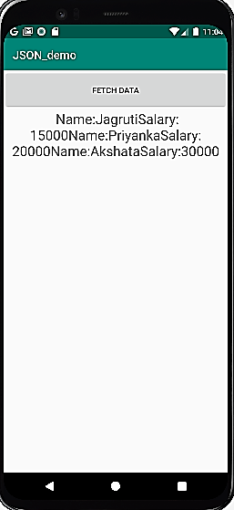

**Practical No.19**

**Aim:** Write an android application to retrieve the JSON object using Volley library and display it in the text view.

**Objective:** To understand the use of Volley Libraries.

**Code:**

**Activity_main.xml**

*<?*xml version="1.0" encoding="utf-8"*?>*<RelativeLayout xmlns:android="http://schemas.android.com/apk/res/android"  
xmlns:app="http://schemas.android.com/apk/res-auto"  
xmlns:tools="http://schemas.android.com/tools"  
 android:layout_width="match_parent"  
 android:layout_height="match_parent"  
 tools:context=".MainActivity">  
 <Button  
 android:id="@+id/button"  
 android:layout_width="288dp"  
 android:layout_height="wrap_content"  
 android:layout_alignParentStart="true"  
 android:layout_alignParentTop="true"  
 android:layout_marginStart="50dp"  
 android:layout_marginTop="159dp"  
 android:text="Get HTTP Request" />  
</RelativeLayout>

**MainActivity.java**

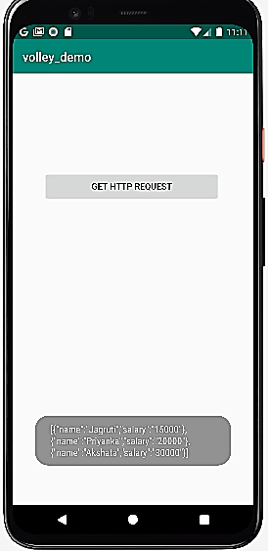package com.example.volley_demo;  
import androidx.appcompat.app.AppCompatActivity;  
import android.os.Bundle;  
import android.view.View;  
import android.widget.Button;  
import android.widget.Toast;  
import com.android.volley.Request;  
import com.android.volley.RequestQueue;  
import com.android.volley.Response;  
import com.android.volley.VolleyError;  
import com.android.volley.toolbox.StringRequest;  
import com.android.volley.toolbox.Volley;  
public class MainActivity extends AppCompatActivity {  
 Button click;  
 private RequestQueue requestQueue;*//Volley is a networking library managed by the RequestQueue* private StringRequest stringRequest;  
 String url="https://api.npoint.io/fd582b7b55d587c224f7";  
 @Override  
 protected void onCreate(Bundle savedInstanceState) {  
 super.onCreate(savedInstanceState);  
 setContentView(R.layout.*activity_main*);  
 click=(Button)findViewById(R.id.*button*);  
 click.setOnClickListener(new View.OnClickListener() {  
 @Override  
 public void onClick(View view) {  
 sendRequestAndPrintResponse();  
 } }); }  
 private void sendRequestAndPrintResponse() {  
 requestQueue= Volley.*newRequestQueue*(this);*//To use it, first you need to instantiate the RequestQueue  
 // Request a string response from the provided URL* stringRequest=new StringRequest(Request.Method.*GET*, url, new Response.Listener<String>() {  
 @Override  
 public void onResponse(String response) {  
 Toast.*makeText*(MainActivity.this, response.toString(), Toast.*LENGTH_SHORT*).show();  
 }  
 }, new Response.ErrorListener() {  
 @Override  
 public void onErrorResponse(VolleyError error) {  
 Toast.*makeText*(MainActivity.this, error.toString(), Toast.*LENGTH_SHORT*).show();  
 }  
 });  
 requestQueue.add(stringRequest);  
 }}

**Output:**